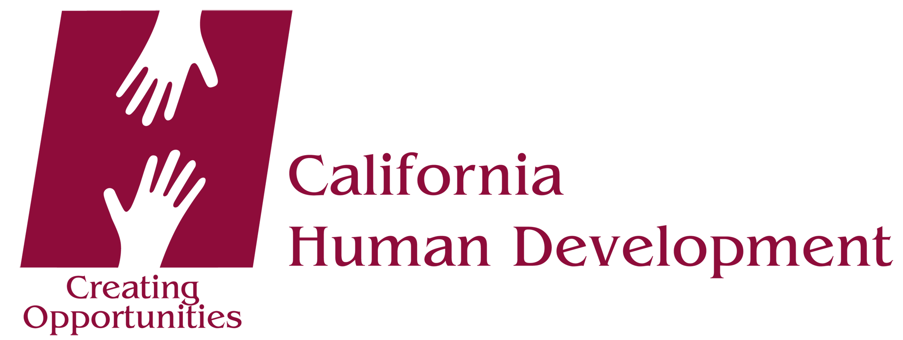

Media Contact:
Kristi Buffo, Communications Manager
707.523.1155, ext. 4715, kristine.buffo@CaHumanDevelopment.org

FOR IMMEDIATE RELEASE

St. Helena Day Labor Center Reopens
Center provides coordinated and safe hiring, fair wage

Santa Rosa, CA (June 29, 2016) – The St. Helena Day Labor Center is back in business following its temporary closure in late 2015. Operated by California Human Development, the center serves an important role in the community by offering day workers and employers an organized and safe setting to connect, arrange services, and negotiate a fair wage. Workers also receive access to important resources, such as health care and benefits screening, courses in English as a Second Language, and emergency aid to meet essential needs such as food and housing.

“We’re pleased to reopen the St. Helena Day Labor Center and are committed to renewing full service to area workers and employers,” says Christopher Paige of California Human Development. “The St. Helen center has traditionally been among our busiest and most-utilized locations—meeting a high demand for day labor services among the agricultural community, building contractors, and homeowners in the Napa Valley region.”

Temporary staffing issues forced the closure of the center but those issues have been solved, says Paige. A newly hired onsite bilingual representative is now in place to assist workers and employers, and the center is open six days a week. A wide range of services can be arranged at the Day Labor Center, such as cleaning, yard work and general maintenance; construction and other skilled labor; packing and moving; farm, ranch and vineyard help; and other jobs as needed.

The St. Helena Day Labor Center is located at The Work Connection at 100 Main Street South. Hours are Monday through Saturday, 7am to Noon. Workers and potential employers are encouraged to arrive early in order to connect, make arrangements and get the job done. Employers may also call 707.963.7805 to speak with CHD’s bilingual staff in advance.

About CHD
California Human Development is a 501(c)(3) non-profit organization and a leader in the War on Poverty for 50 years. Inspired in service to our state’s farmworkers, today CHD serves people of low income from many walks of life—giving 25,000 people a year in 31 counties a hand up to the American Dream. Training & Jobs, Affordable Housing, Immigration & Citizenship, disABILITY services, and Drug-Free Living programs create opportunities to end poverty.

###

